Title [Aptos, 18pt, bold]

N. Surname¹, N. Surname², …[Aptos, 11 pt, italic; underline presenter’s name]

¹ Department and institution of affiliation, Address, Country
² Department and institution of affiliation, Address, Country
…

Email: presenter@aie7.it

The body of your abstract begins here. The abstract should be a concise summary of your poster/oral presentation and should present your scientific activity. It should be typed single-spaced in 12 point “Aptos ” giustified. Please do not change any font styles and their sizes. The abstract may also include figures, which must be quoted in the text (Figure 1).

References [1,2] should be single-spaced, typed in “Aptos” size 10, and placed at the end of the text.
Save the document as “Surname_Name_oral.docx” or “Surname_Name_poster.docx” in Microsoft Word format (.doc or .docx).
Please upload your abstract using the submission form on the symposium website.

Maximum length: one page.
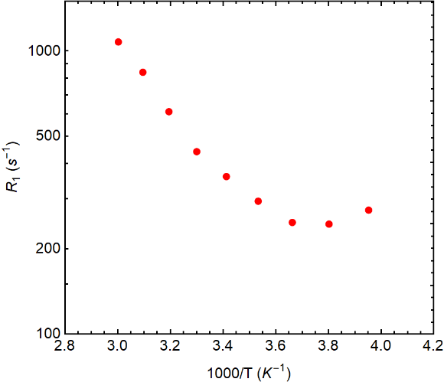
Figure 1. Font: Aptos, 10 pts, Italics, aligned to the center. Figures must be quoted in the text.

[1] J. Luo, T. Ben Zhong et al. 2001 Chemical Commun., 1740
[2] P. Morris et al. 2008 Phys. Rev. Lett., 70, 214

